HOL Plant Photosynthesis Lab
Go to the HOL website and look over the lesson material for the enzymes lab. Do the lab and fill out my worksheet below and submit that. It follows my usual convention of data tables, summary and picture.
Plants take in Carbon dioxide and water. They use light to convert the carbon dioxide into the complex carbon molecules of which they are made. This process of photosynthesis produces oxygen as a waste by-product. This is good for animals like us since we need oxygen to live.
This lab is meant to demonstrate that both light and carbon dioxide are necessary for oxygen production: Some leaf samples will be kept in the light, others in the dark. Samples in the presence of bicarbonate (dissolved CO₂) will have ample carbon dioxide. Samples in distilled water will be deprived of carbon dioxide.
Briefly, you will cut disks out of leaves and immerse them in either distilled water or bicarbonate solution. Gasses will be extracted from the leaf disks by applying a vacuum to the solution they are in. This will cause the leaves to sink. Leaf disks in the presence of both light and carbon dioxide are expected to produce oxygen as they engage in photosynthesis. This will cause them to float after some time. You will record the time it takes for them to float, for up to 20 minutes.
You will just be doing exercise 1. Hastily copied and modified procedures are below in case you don’t have access to the HOL website.
Substitutions:
If you are missing essential components from your kit, consider the following:
1. Single-hole paper punches (the kind you use to make holes in paper for three-ring binders) can be purchased from office-supply sections in department stores, drugstores or office supply stores.
2. Plastic syringes can be purchased from drugstores. Get the largest size you can.
3. Leaves other than spinach leaves can be used. Fresh leaves from outdoors are OK.
4. Sodium bicarbonate is baking soda.
5. If you don’t have a scale, measure out a teaspoon of sodium bicarbonate.
6. Spring water is a good substitute for distilled water.

HOL PHOTOSYNTHESIS WORKSHEET Name:

Table 1. Number of Floating Leaf Disks at Various Ttimes.
Time (min) | Light + Bicarbonate | Light +  Water | Dark + Bicarbonate | Dark +  Water
0 | 0 | 0 | 0 | 0
2 | 2 | 0 | 0 | 0
4 | 3 | 0 | 0 | 0
6 | 5 | 3 | 0 | 0
8 | 10 | 5 | 0 | 0
10 | 10 | 9 | 0 | 0
12 | 10 | 10 | 0 | 0
14 | 10 | 10 | 0 | 0
16 | 10 | 10 | 0 | 0
18 | 10 | 10 | 0 | 0
20 | 10 | 10 | 0 | 0

Figure 1. Graph of Leaf Floatation Times for Disks in Bicarbonate exposed to Light.
(Just plot the Light + Bicarbonate data only. You can plot by hand or use a spreadsheet like Excel.)

Summary of Results:
- Summarize your results in your own words. If anything did not go as expected then explain what you think caused this to happen.

The leaf discs in the bicarbonate solution that was placed under light were able to perform photosynthesis. This made them to produce a lot of oxygen in a short period of time and become buoyant. The buoyancy brought about by the oxygen made the leaf discs to float. A similar process occurred in the d
Light plus water container but the rate of floating was slower as there was less carbon dioxide needed for photosynthesis to happen.
The leaf disks that were placed in the dark did not float as there was no light to support photosynthesis.

Picture of You with Your Lab:
Please include a picture of you with your lab setup:

Exercise 1 - Carbon, Light, and Photosynthesis
In this exercise, you will investigate the relationship of carbon availability, light, and their impact on photosynthesis. You will determine whether or not significant rates of photosynthesis are occurring in spinach leaves placed in distilled water and sodium bicarbonate solutions while in light and dark environments.
STAGE 1: Preparing your leaf disks.
- Add distilled water to a paper towel until it is moist but not dripping with water.
- Use a single-hole paper punch to cut 40 uniform disks from the spinach leaves. Avoid cutting out major leaf veins, which are for vascular transport and contain fewer chloroplasts. See Figure 4.
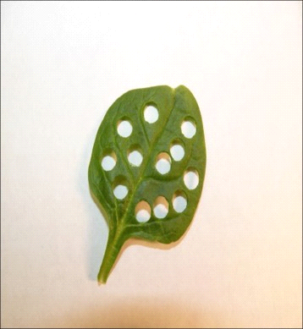 Figure 4. Disks cut from a spinach leaf.
3. Place the leaf disks onto the moistened paper towel as soon as you cut them out.
4. Once all leaf disks have been cut out, lay an additional paper towel that has been moistened with distilled water over the disks. Set the disks aside until Stage 3: step 1.
5. Locate the 2 clear plastic cups provided in your kit. Use the permanent marker to label the first plastic cup “bicarbonate solution” and the second plastic cup “distilled water solution.”
6. Use scissors to cut a small square of paper to be used as weigh paper. Fold the paper in half once, and again, creating a small, folded square. Unfold the paper to its original size. The creases in the weigh paper will help direct all substances to the center of the paper and avoid scattering or spilling. See Figure 5.
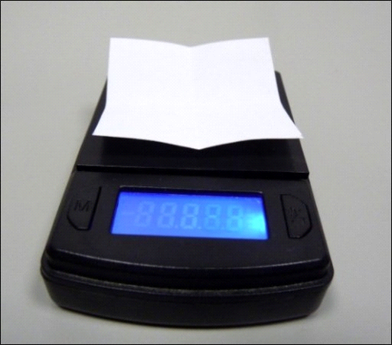
Figure 5. Weigh paper and digital scale.

STAGE 2: Preparing your sodium bicarbonate and distilled water.
- Turn on the digital scale and place the weighing paper on the scale. Tare the scale so that it reads “0.0 g.”
Note: To tare the scale, press the power button once. The scale should read 0.0 g while the weighing paper rests on the weighing platform.
2. Weigh 0.4 g of sodium bicarbonate (NaHCO₃, baking soda). Transfer the measured sodium bicarbonate to the plastic cup labeled “bicarbonate solution.”
3. Use the 50 mL graduated cylinder to add exactly 200 mL of distilled water to the cup labeled “bicarbonate solution.”
Note: To add a total of 200 mL, you will need to make 4 additions of exactly 50 mL of distilled water.
Note: The sodium bicarbonate solution is composed of approximately 0.001% carbon in the form of bicarbonate ions. In comparison, atmospheric air is approximately 0.04% carbon in the form of carbon dioxide.
4. Use a clean spoon to mix the contents of the cup until the sodium bicarbonate is dissolved.
5. Use a long stem pipet to add 2 drops of liquid dish soap to the “bicarbonate solution” cup. Gently and slowly mix the solution in wide circular motions with the pipet stem for a few moments, but try to avoid making suds. Discard the pipet in a trash bin.
Note: The soap will assist the movement of sodium bicarbonate solution into the leaf disks by degrading the leaf’s waxy cuticle.
6. Use the 50 mL graduated cylinder to add exactly 200 mL of distilled water to the cup labeled “distilled water solution.”
7. Gather the other empty, long-stem pipet and use it to add 2 drops of liquid dish soap to the “distilled water solution” cup. Use the pipet stem to gently and slowly mix the solution in wide circular motions for a few moments, but try to avoid making suds.
8. Label four additional 9 oz. plastic cups with the following varying solution and light treatments:
- “Distilled water, light”
- “Distilled water, dark”
- “Sodium bicarbonate, light”
- “Sodium bicarbonate, dark”
9. Use the graduated cylinder to measure and add 75 mL of the distilled water solution to each of the 2 cups labeled “distilled water, light” and “distilled water, dark.” As you pour the solution, tilt the graduated cylinder and pour the solution into the cylinder down its side to minimize suds. See Figure 6.
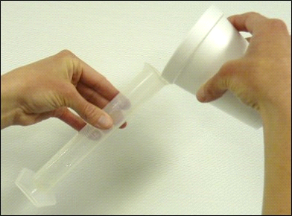Figure 6.
Transferring solution to a graduated cylinder at an angle.
10. Now, add 75 mL of the sodium bicarbonate solution to each of the 2 cups labeled “sodium bicarbonate, light” and “sodium bicarbonate, dark.” As you pour the solution, again tilt the graduated cylinder at an angle to minimize suds.
Note: The cups with distilled water will serve as controls since they contain no source of excess carbon dioxide.
STAGE 3: Degassing your leaf disks.
- Remove the plunger from the syringe and place 20 leaf disks in the syringe barrel. Replace the plunger. Do not crush the leaf disks, but push the plunger into the barrel until only a small air space is left in the barrel along with the leaf disks.
- Slowly draw 3 mL of the “distilled water solution” into the barrel of the syringe.
- Hold the syringe so that the nozzle faces upward. Swirl the solution in the syringe to ensure that all of the leaf disks are suspended. Gently tap or flick the side of the syringe so that all of the small air bubbles that may be attached to the disks or the inside of the syringe rise to the top of the syringe.
Note: Do not shake the syringe or tap too hard, as this may cause additional air bubbles to attach to the disks.
4. With the syringe nozzle facing upward, expel any air within the syringe barrel by slowly pushing the plunger upward until no air remains.
5. Place 1 finger over the nozzle of the syringe. Using the other hand, pull downward on the plunger so that a vacuum is created within the barrel. See Figure 7.
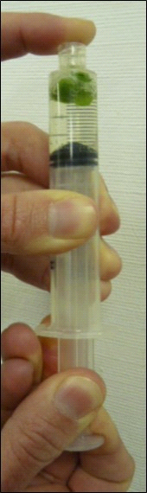 Figure 7. Creating a vacuum in the syringe.
6. While holding both hands in place, gently move the syringe in a circular motion for a few moments so that the leaf disks mix with the solution.
Note: Do not shake the syringe.
7. Slowly release the vacuum by releasing tension on the plunger while keeping your finger on the syringe opening. This procedure will cause the solution to enter the internal spaces of the leaf disks.
8. Repeat Stage 3 steps 5 through 7, creating a vacuum until each leaf disk sinks to the bottom of the plunger. See Figure 8.
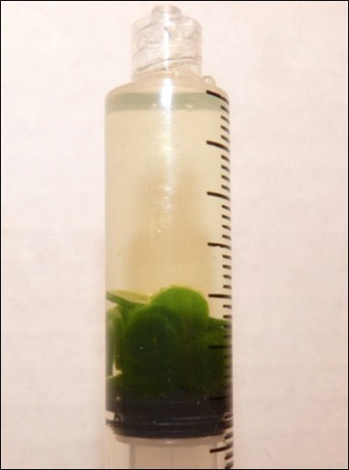 Figure 8. Plunger with all 20 leaf disks at the bottom of the solution.

STAGE 4: Setting up your cups.
- Fold a paper towel in half and place it on a work surface. Transfer the contents of the syringe to the paper towel. To do this, hold the syringe so the nozzle is pointing downward. Pull the plunger up to the end of the barrel without fully removing it. Place your finger over the syringe nozzle and remove the plunger from the syringe. Pour the entire contents of the syringe onto the paper towel. Gently tap the syringe on the paper towel to transfer any leaf disks that may have stuck to the inside of the syringe barrel.
- Transfer 10 wet leaf disks to the “distilled water, light” cup. Transfer the remaining 10 wet leaf disks to the “distilled water, dark” cup. The leaf disks should sink to the bottom of the cup.
- Place the cups containing the leaf disks in a small box, such as a shoe box, to create a dark environment. Using a dark cabinet or closet in lieu of a box is also acceptable.
- Discard the wet paper towel in a trash bin. Rinse the syringe barrel and plunger with distilled water.
- Repeat Stage 2 step 9 through Stage 4 step 1, using the sodium bicarbonate solution instead of the distilled water solution. Transfer 10 wet leaf disks to the “sodium bicarbonate, light” cup. Transfer the remaining 10 wet leaf disks to the “sodium bicarbonate, dark” cup. Place the cups in the box until you are ready to begin the timed portion of the experiment.
- Position a desk lamp on your workspace so that the light bulb will rest about 1-2 ft. above the work surface. A 60-watt or higher incandescent bulb or 13-watt or higher compact fluorescent bulb will work well. Do not turn on the lamp until Stage 5 step 4.
WARNING!
Do not use a light bulb with a wattage exceeding the design capacity of the lamp. Use the lamp in accordance with the manufacturer’s instructions.
STAGE 5: Running the experiment.
- In the following steps of the procedure, the cups labeled “light” will be placed under the lamp and the cups labeled “dark” will remain shielded from light in the box. Leaf disks that undergo photosynthesis will produce oxygen. When enough oxygen is produced, the disk will become buoyant and float to the top of the solution. Create a hypothesis for whether or not each cup will contain leaf disks that become buoyant. Record your hypothesis in Data Table 1.
- While the cups are still in the box, observe the number of floating disks in each solution. Record the number of floating leaf disks for each cup at zero minutes in Data Table 1.
- Remove the “distilled water, light” and “sodium bicarbonate, light” cups from the box. Place each cup under the desk lamp so that each cup will receive an equivalent amount of light. See Figure 9. Allow the “distilled water, dark” and “sodium bicarbonate, dark” cups to remain in the box.
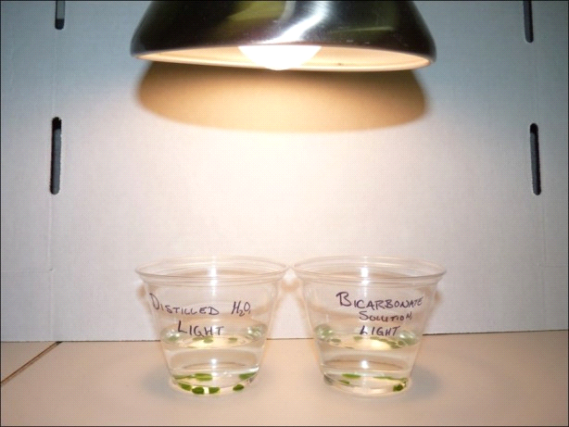Figure 9.
Light environment setup.
4. Begin timing the experiment with a kitchen timer or clock with a second hand and immediately turn on the light.
5. In MY Table 1, record the number of floating disks every 2 minutes for up to 20 minutes. Do this for both cups in the light environment and both cups in the dark environment. Swirl the cups occasionally to ensure that none of the disks are stuck to one another or to the bottom of the cup.
7. Remove the 2 cups labeled “light” from under the lamp and place them in the box. Wait 20 minutes and let me know if the disks sink in your summary. Why do you think they would sink?
Note: The number of floating disks at zero minutes in Data Table 2 should equal the number of floating disks at 20 minutes in Data Table 1.
9. Create a line graph using the data from Table 1. Plot time on the independent axis (x-axis) and the number of floating disks on the dependent axis (y-axis). Just plot the Light + Bicarbonate data only. You can plot by hand or use a spreadsheet like Excel.

Cleanup:
- Discard the used bits of leaves in the trash when complete.
- Pour the bicarbonate solutions down the drain.
- Use the dish soap and brush to wash your cups.
- Return all items to the lab kit for future use.

